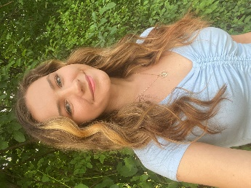**Alexandra Grace Nowak**

(716)-534-5838

[alexnowak58@gmail.com](mailto:alexnowak58@gmail.com)

AlexandraGraceNowak.com

Height: 5’5”

Vocal Range: Mezzo Soprano

|  |  |  |
| --- | --- | --- |
| **THEATRE:**  Chicago  The Little Mermaid  Matilda  42nd Street  Scrooge the Musical  Charlotte’s Web | Hunyak/Ensemble  Arista/Princess #3  Miss Honey  Company  Company  Gander | O’Connell & Company  Lockport Palace Theatre  Lockport Palace Theatre  Lockport Palace Theatre  Lockport Palace Theatre  Lancaster Opera House |
| **WORKSHOP PRODUCTIONS:**  Birds & Bats | Alfred Pennyworth/Reflection | Sidekick Productions |
| **FILM, COMMERCIAL & MEDIA:**  Bed N’ Breakfast on Acid (Short Film)  House of Holiday (Commercial)  The American Side (Film)  The POWcast (Podcast) | Mellissa Wagner  Featured Shopper  Tourist  Various Roles | Captain Unique Productions for the Buffalo 48 Hour Film Project  YouVision Media  One Horse Shy Productions  Sidekick Productions |
| **CONCERTS:**  Carmina Burana  West of the Mark | Chorus  Featured Vocalist | ArtPark with La Fura Dels Baus  The Stage WNY |
| **EDUCATIONAL THEATRE:**  Grease  Songs From Across The Pond | Rizzo  Company | Marymount Manhattan College  (Dir. Ray DeMattis)  Marymount Manhattan College  (Dir. Larry Fuller) |

**TRAINING:**

Marymount Manhattan College BA Musical Theatre

**Acting:** Ellen Orenstein, Patricia Hoag Simon, Antonio Edwards Suarez

**Dance:** Jeff Shade,Kyle Pleasant, Lori Leshner, Rommy Sandhu, Jessica McRoberts

**Voice:** Paul Katz, Michael Hooker

**SPECIAL SKILLS:**

Experience learning & performing various languages (Hungarian & Italian) and accents (Proper English & NY), cheerleading experience, painting, archery, stage combat training, ukulele, and can say supercalifragilisticexpialidocious backwards.